LAB 5 – QUERIES AND SUBQUERIES

1. SQL Query
A query is a SQL statement used to retrieve or manipulate data from a database.
Basic Syntax
SELECT column1, column2
FROM table_name
WHERE condition;
Example
SELECT Name, Marks
FROM Student
WHERE Marks > 80;
This displays the name and marks of students who scored more than 80.
5. Subquery
A subquery is a query written inside another SQL query.
It is also called a nested query or inner query.
General Syntax
SELECT column
FROM table
WHERE column operator
(
SELECT column
FROM table
WHERE condition
);
A subquery generally consists of:
- Inner query – executes first and produces a result.
- Outer query – uses the result of the inner query.
Example
SELECT Name, Marks
FROM Student
WHERE Marks > (
SELECT AVG(Marks)
FROM Student
);
The inner query calculates the average marks. The outer query then displays students whose marks are greater than that average.



PART A – 7 SQL QUERIES
Query 1: Display all students
SELECT *
FROM Student;
Purpose: Displays all columns and all records from the Student table.


Query 2: Display selected student details
SELECT Name, Department, Marks
FROM Student;
Purpose: Displays only the student's name, department and marks.

Query 3: Display students scoring more than 80
SELECT Name, Marks
FROM Student
WHERE Marks > 80;
Purpose: Displays students who scored more than 80 marks.

Query 4: Display CSE students
SELECT Name, Marks
FROM Student
WHERE Department = 'CSE';
Purpose: Displays students belonging to the CSE department.


Query 5: Display students from Delhi scoring more than 80
SELECT Name, Marks
FROM Student
WHERE City = 'Delhi'
AND Marks > 80;
Purpose: Displays students who are from Delhi and scored more than 80.

Query 6: Find the highest marks
SELECT MAX(Marks) AS Highest_Marks
FROM Student;
Purpose: Finds the highest marks obtained by a student.

Query 7: Find the average marks
SELECT AVG(Marks) AS Average_Marks
FROM Student;
Purpose: Calculates the average marks of all students.

PART B – 7 SUBQUERIES
Subquery 1: Students scoring above average
SELECT Name, Marks
FROM Student
WHERE Marks > (
SELECT AVG(Marks)
FROM Student
);
Purpose: Displays students whose marks are greater than the overall average marks.
Working:
Inner query:
SELECT AVG(Marks)
FROM Student;
Finds the average marks.
Outer query:
SELECT Name, Marks
FROM Student
WHERE Marks > average;
Displays students scoring above the average.


Subquery 2: Student with the highest marks
SELECT Name, Marks
FROM Student
WHERE Marks = (
SELECT MAX(Marks)
FROM Student
);
Purpose: Finds the student or students who obtained the highest marks.

Subquery 3: Students scoring more than Rahul
SELECT Name, Marks
FROM Student
WHERE Marks > (
SELECT Marks
FROM Student
WHERE Name = 'Rahul'
);
Purpose: Displays students whose marks are greater than Rahul's marks.
Working:
The inner query finds Rahul's marks. The outer query compares every student's marks with Rahul's marks.

Subquery 4: Students from the same department as Rahul
SELECT Name, Department
FROM Student
WHERE Department = (
SELECT Department
FROM Student
WHERE Name = 'Rahul'
);
Purpose: Displays students who belong to the same department as Rahul.
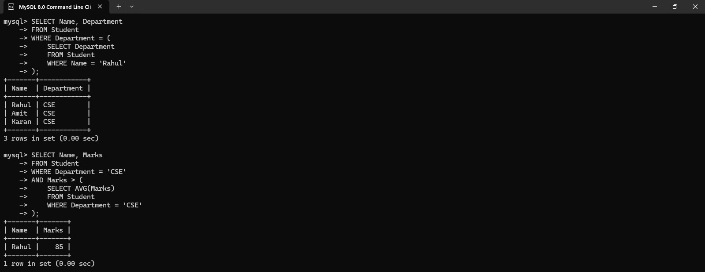

Subquery 5: CSE students scoring above the CSE average
SELECT Name, Marks
FROM Student
WHERE Department = 'CSE'
AND Marks > (
SELECT AVG(Marks)
FROM Student
WHERE Department = 'CSE'
);
Purpose: Finds CSE students whose marks are greater than the average marks of CSE students.

Subquery 6: Students whose department is among Mumbai students
SELECT Name, Department
FROM Student
WHERE Department IN (
SELECT Department
FROM Student
WHERE City = 'Mumbai'
);
Purpose: First finds the departments of students from Mumbai and then displays students belonging to those departments.
Important:
IN is used when the subquery can return multiple values.


Subquery 7: Students scoring higher than all ECE students
SELECT Name, Marks
FROM Student
WHERE Marks > ALL (
SELECT Marks
FROM Student
WHERE Department = 'ECE'
);
Purpose: Displays students whose marks are greater than every ECE student's marks.
Important:
ALL means the condition must be true for every value returned by the subquery.

6. IN and ALL in Subqueries
IN
IN is used to compare a value with multiple values returned by a subquery.
WHERE Department IN (
SELECT Department
FROM Student
WHERE City = 'Mumbai'
);
ALL
ALL compares a value with every value returned by a subquery.
WHERE Marks > ALL (
SELECT Marks
FROM Student
WHERE Department = 'ECE'
);
Easy Difference
Operator | Meaning
= | Equal to one value
IN | Matches any value in a list
ALL | Condition must satisfy every returned value

Quick Revision
7 SQL Queries
- SELECT *
- SELECT specific columns
- WHERE Marks > 80
- WHERE Department = 'CSE'
- WHERE City = 'Delhi' AND Marks > 80
- MAX(Marks)
- AVG(Marks)
7 Subqueries
- Marks greater than average
- Student with maximum marks
- Marks greater than Rahul
- Same department as Rahul
- Above CSE average
- Department IN departments of Mumbai students
- Marks greater than ALL ECE students
Remember the basic structure:
SUBQUERY
↓
┌─────────────────┐
│ Inner Query │
└────────┬────────┘
↓
Result/value
↓
┌─────────────────┐
│ Outer Query │
└────────┬────────┘
↓
Final Result

